C O N F I D E N T I A L

TRIP REPORT ST. JOE FLAME REACTOR FUMING TESTWORK

WITH TSUMEB BLAST FURNACE SLAG

August 3 - 28, 1987

Distribution:

Manager Metals Production Chief Metallurgist

R. & D. Files Smelter Files

1. SUMMARY

A pretest was conducted by St. Joe Minerals Corporation on August 13, with ground Tsumeb blast furnace slag using pulverized coke as a fuel. This trial was successful (flame stability) and based on the results from this test-run (73"/4 Zn recovery, 73% Ge recovery, 13% Ga recovery to oxide fume) a factorial test matrix was decided on, investigating the influence of the following four parameters on Flame Reactor performance:

Slag feed rate 18 - 27kg/min.)

% 02 in oxidant 50 - 70% 02

CO/CO2 ratio 0,25 - 0,50

Temperature 1600 - l800°C

(The temperature is calculated at the exit of the reactor prior to re­ oxidation of the metal vapours).

However, since change-over from coke to coal, pre-ignition of coal occurred in the upper pilot section of the reactor. This resulted in a back pressure on the coal feeding equipment above. Coal feed rates were thus fluctuating and so flame conditions in the reactor. Various attempts were made to reduce the fluctuations in coal feed rates, but the problem could not be solved completely. Only two test trials were conducted under "normal", stable conditions. The other six trials of the test matrix were

completed with relatively unstable coal feed rates. Assay results for these trials were not yet available at the time of my departure.

Two more test trials were subsequently repeated with coke as fuel and the intention was to do some test trials with elemental sulfur additions to the slag feed (sulphide fuming).

Once assay results for the test matrix trials have been received, optimum test conditions will be chosen for the intended coarse slag trial (Planned for September 2, 1987).

Apart from the coal burner/feeder problem experienced, the St. Joe Reactor proved itself as a versatile and easy to operate process for the treatment of Tsumeb slag. However, the following warrants discussion:

1.1. The longest non-interrupted run achieved with this demonstration plant was 19 hours, while their longest "continuous" run lasted 5 days at an on-line time of 60% only (See Section 4,0 for reasons).

1.2. Both top and middle sections of the reactor last for 60 shifts only before water leaks appear. (See Section 4,0).

1.3. Test trials with Tsumeb slag were conducted at maximum feed rates of 27 kg/min or 39 m.tons/day. For a 300 t/d fuming plant a scale-up factor of 7 to 8 should thus be applied. St. Joe has only scaled up their reactor once by a factor of 2 to 3.

2. INTRODUCTION

In April 1987 a total of 56 m. tons Tsumeb lead blast furnace slag, reclaimed from the "old “blast furnace slag stockpile (See Annexure l for chemical analysis) was dispatched to the St. Joe Minerals Corporation's Technical Centre for fuming testwork in their flame reactor, 47 m.tons thereof having been ground in a Babcock E 38 mill to 79,6% minus 74 µm.

Objectives for the test program were:

2.1. To produce zinc oxide and slag products for subsequent process testwork by MINTEK and to generate metallurgical and operating data to evaluate process performance;

2.2. To develop preliminary capital and operating cost estimates for a 100 000 m.ton per year Flame Reactor process facility, based upon the plant trial results; and

2.3. To develop a proposal to provide a plant engineering and licensing package for the commercial plant.

3. FLAME REACTOR TEST EQUIPMENT

3.1. Flow Diagram

See Figure 1.

Figure 1

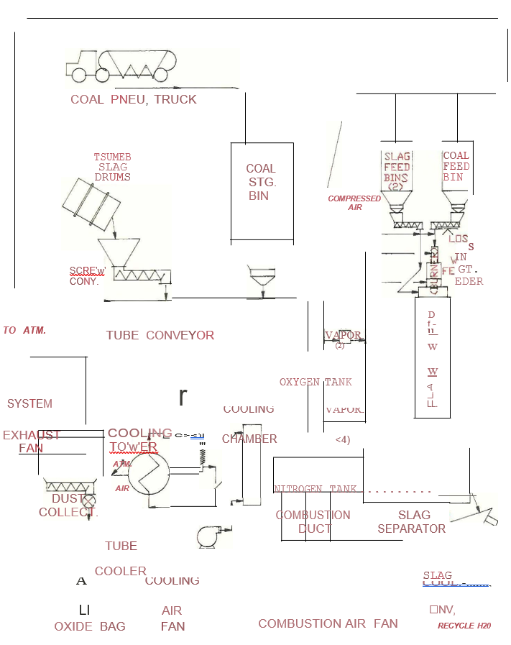

3.2. Metallurgical Feed Handling And Storage

The Tsumeb slag was fed via a screw conveyor to the receiving hopper of a six-inch ID enclosed Hapman mechanical tubular conveyor. This tubular conveyor transports both slag and fuel to one of three elevated day bins through individual discharge gates and chutes.

The existing 46,7 cubic metre metallurgical feed storage silo was not used during this test period for storage of Tsumeb slag.

Two slag bins (4,2 cubic metres each) were used for metallurgical feed storage, vented to a common cloth collector. Both bins are mounted on a set of three shear beam load cells for inventory and feed rate measurements. Slag is discharged from the day bin through a 914mm Siletta live­ bottom feeder into a surge hopper set above a volumetric metering feeder, feeding the slag into the reactor via a

2-inch pneumatic injection line.

3.3 Coal Feed Handling And Storage

The coal was unloaded and conveyed pneumatically from a tanker into the in-door storage silo (36,8 cubic metres). A dedicated baghouse on top of the silo is used for ventilation. Fuel is removed from the storage silo by a 762mm

square, live-bottom bin discharging feeder via a screw conveyor into the receiving hopper of the six-inch ID enclosed mechanical tubular conveyor. The tubular conveyor trans­ ports the coal to the elevated coal day bin through an in­ dividual discharge gate and chute.

The 3,7 cubic metre fuel day bin is mounted on a set of shear beam load cells for inventory control and additional feed rate calculations. Fuel is withdrawn from the day bin through a 914 mm Siletta live-bottom feeder and feeds an Acrison Model 403-4000-1200-BDF 2,5 K Gravimetric Feeder The feeder package includes an MD II Weigh Feeder Controller. The MD II is a self-contained computer, capable of controlling fuel rate and can communicate with the Modcomp 11/25 data acquisition computer.

Fuel is discharged from the Gravimetric Feeder by a volumetric screw feeder, after being homogenized by two additional short screw spirals, into the coal feed pipe where pneumatic conveying air is added.

3.4. Reactor

The reactor includes a first-stage or pilot section (12) (See Figure 2) consisting of an upper pilot (section 14) mounted vertically and coaxially above the lower pilot (section 16),the gas injection chamber (section 18), the feed injection chamber (section 22),reactor shaft (100) and

finally the outlet section (102). The upper pilot (section 14), lower pilot (section 16) and gas injection section (18) together comprise the first stage, while the feed injection section (22) and 3 reactor sections (100) together comprise the second stage.

Figure 2

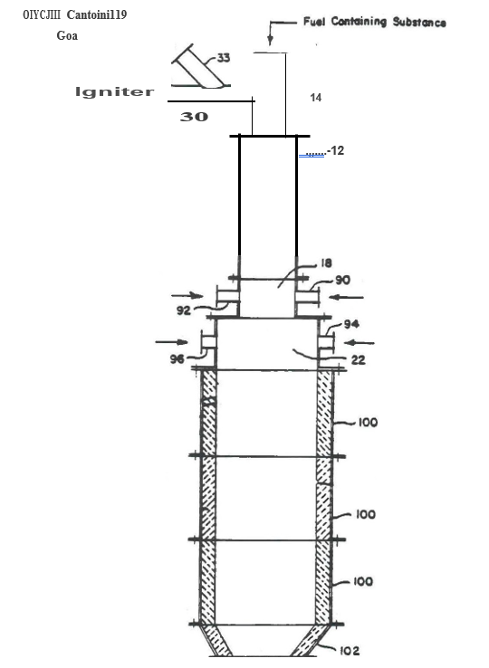

The pulverized coal is discharged by the volumetric screw feeder (20) (See Figure 3) into a short transition pipe (23), reducing the coal feed pipe diameter to 4 inches, followed by an automatic controlled isolation valve (24), a T-junction for ambient air intake (25), another T-junction containing the pneumatic conveying air nozzle (26), an orifice plate and a flexible connection pipe (27) before discharging into the upper pilot (section 14). Also, a simple flow distributing device in the upper pilot (section

14), just above the tangential combustion air inlet pipe (33) serves to distribute the coal/air mixture evenly in the coal feed pipe.

Whenever the plant is shut down, the coal isolation valve

(24) is closed while the ambient air inlet valve (25) simultaneously open. The orifice plate is said to isolate the coal metering arrangement, above, from pressure surges in the reactor below.

The rest of the reactor is described in detail by Pusateri et.al. in their U.S. Patent No. 4654077 (See Annexure 3). The patent also covers their view on scale-up and sizing of the reactor.

3.5. Separator

The separator is refractory-lined as well as water cooled. It measures about 1,8 metres long x about 1,0 metre ID, with a 305 mm (12") ID tangential reactor inlet, 457 mm (18") ID off-gas outlet and 150mm ID slag taphole. The large diameter "open" taphole is of great advantage to observe process/flame conditions during start-up as well as normal operations.

The slag is tapped onto a (non-contact) water cooled vibrating conveyor table whereupon it freezes before discharge into a metal container.

3.6. Off-Gas System

After combustion of the metal vapours and combustibles occurs in a refractory lined 457 mm ID x 4 m long duct to which combustion air is supplied by a separate blower. The after com­ busted stream is cooled with air (from cooling air fan) in a 1,5 m wide x 2,1 m long x 3,6 m high refractory lined cooling chamber. This chamber also serves as a drop out box for entrained slag. Additional cooling is obtained by passing the

stream through a shell and tube heat exchanger 136 tubes cont3ining 82,5 mm ID and 6,0 m long (off gas on the inside of the tubes).

Final off gas temperature control is done by sucking in ambient air immediately up-stream of the jet-pulse dust collector.

The baghouse is equipped with 827 m2 of Teflon coated Nomex

cloth, running at an air-to-cloth ratio of 2,0 - 4,0 (ft./min.). Pressure drop over the bags is 4-811 H2o (1-2 kPa).

Suction is maintained in the reactor and off-gas system with a damper controlled I.D. fan after the baghouse.

3.7. Combustion Gas Feed System

Oxygen and nitrogen are obtained from on-site liquid cryogenic storage tanks (35 000 litres each) via sets of two and four fan ambient evaporators, respectively. Each evaporator has a capacity of 850 Nm3/h. Gaseous oxygen and nitrogen streams are regulated by separate pressure control manifold stations supplying 690 kPa gas to the plant.

Process and plant air is supplied by an on-site air compressor (rated at 1100 Nm3/h@ 690 kPa). This air is used as

combustion gas as well as instrument air, dust collector pulsing and utility needs.

3.8. Computer Data Acquisition And Process Control

The system utilizes a Modcomp II/25 computer to scan up to 50 thermocouples, 200 digital inputs, 100 high level analog inputs and 13 load cells, every two seconds. "Live" (two­ second) data are accessible via two terminals in the control room. The data are also stored as one-minute averages for possible on-line process monitoring and trend analysis by the project engineers. These data are accessible at three additional terminals located in the Technical Center Office Building.

All one-minute average data are printed in report formats after each test. This information is used for post-test analysis of process performance via a thermodynamic computer model and a computerized reconciliation of the flame reactor material balance.

A Modicon 584 PLC (Programmable Logic Controller) is used to scan digital signals such as motor and switch status limit switches and alarm contacts. This unit permits the engineer to specify (in software) the exact logic/interlocks to be used to activate specific outputs depending upon the state of various inputs. One key safety feature is the ability to interlock motors and valves to shut down the plant in a safe and orderly fashion by activating one main control button on the control panel.

Parameters like o2 flowrates, N2 flowrates, fuel and feed conveying air flow rates, reactor pressure, etc. are all controlled at manually adjusted set points by stand-alone

Fisher indicator/controllers. Gas flow rates are measured by both vortex and orifice flow meters.

Measuring of the reactor flame temperature was so far not successful. A pyrometer is used for relative indication of the flame temperature. This pyrometer is situated in the gas injection section (lower part of the upper pilot).

Reactor gases are sampled through a water cooled probe, and analyzed with a batch gas chromatograph and a non-dispersive infrared (NDIR) analyzer to determine the gas composition and CO/CO2 ratio at the exit of the reactor. Unfortunately the gas chromatograph was not functional during the test period with Tsumeb slag.

4. OPERATING PRACTICE

The St. Joe Flame Reactor Process is well described by Pusateri in:

Reinhardt Schuhmann International Symposium on Innovative Technology and Reactor Design in Extraction Metallurgy, November 1986 and U.S. Patent No. 4654077, dated March 31, 1987 (Annexure 3). However, the following additional comments apply:

The longest non-interrupted run achieved with this demonstration plant was 19 hours, while their longest "continuous" run lasted for 5 days with a reactor availability of 60%. The reasons for this poor performance are:

1. the off gas system being inadequate

2. the fuel and metallurgical feed storage and conveying equipment not being able to keep up with feed rates.

Test points are planned such (lower feed rates, higher o2 enrichment) that baghouse air to cloth ratios will not exceed 3,5 ft/min., which is low for a jet-pulse cleaned baghouse. In spite of this low

initial air to cloth ratio the baghouse pressure drop could increase from 4 to 10 11 H20 during an 8 hour shift, causing the reactor to run

under pressure. Should this happen, the plant is usually shut down for= l hour for the baghouse cleaning cycle to catch up. (Pulse cleaning is done on a continuous timed cycle).

Another bottleneck in the off-gas system is the tube cooler. Depending on the type of material treated in the reactor (halogen content) these tubes could block up within 3 shifts such that the plant needs to be shut down for clean-up. During the Tsumeb slag test period these tubes did not block up at all.

The third constraint in the off gas system is the after burner duct between the separator and the cooling chamber. Depending on the material treated also this duct could build-up with slag carry-over from the separator such that the plant needs to be shut down for clean-up. In an industrial plant the plan is to install the cooling chamber directly behind the separator, serving as an entrained slag drop-out box as well as an after burner.

The slag separator efficiency is said to be 95%, i.e. 5% of the theoretical slag yield does not report to the tapped slag. About 4% is carried through to the baghouse as unreacted feed, coal ash, very fine slag particles or anything in between. Less than 1% settles in the cooling chamber as a coarse but loose dust and as a fused pro­ duct in the after burner duct.

Construction of the three reactor sections (A, Band C from top to bottom) is well described in their U.S. Patent. However, both sections A and B (Top and middle), subjected to the hottest part of the flame, has a life time of 3 months only before water leaks into the reactor appear. The bottom section has a life time of 8 - 9 months while the transition piece between reactor and separator has never been replaced. The intention is to test a tube

coil cooled reactor section. It is said that the industrial reactor will only have one long reactor shaft section and not three sections

- the weak area of the sections being at the flange welding seams. Also, scaling is part of the local overheating problem in their re­ actor sections. Proper cooling water treatment should thus solve part of the problem.

Reactor pressure is maintained at -0,3" H2o for two reasons:

1. the potential danger of CO-gas leaks between reactor section flanges (No packing material is used between flanges),

2. any back-pressure on the coal feed pipe causes the Acrison coal feeder flow rate readings to become totally unreliable.

However, because of the flow restriction at the transition piece between reactor and separator, a small negative pressure in the reactor can only be achieved by maintaining a relatively high negative pressure in the separator, causing a large amount of cold ingress air to flow through the 150 mm diameter taphole. This cold air tends to cool the liquid slag in the separator and contributes to a large extend for the liquid slag carry-over into the after burner. This, of coarse, is a large source of after combustion air.

The reactor is ignited with a natural gas burner. As soon as the natural gas is ignited, the combustion gases needed for coal combustion is introduced in equal amounts through the upper pilot gas in­ let and through the gas injection section, and the coal feeder is activated. As soon as the pyrometer (gas injection chamber level) gives a reading above say 6000 , the natural gas burner is shut off.

Coal ignition usually occurs within 2 or 3 mins. The reactor is

then heated up for -+ 45 mins. at this reduced coal feed rate (-+5 kg/min.) before increasing the coal and gas flow rates and introducing the metallurgical feed. Molten slag starts to run from the separator usually within 3 min after introduction of the met. feed.

The plant is run in a semi-automatic controlled fashion, i.e. for any one test trial the following set points are specified by the Project Engineer:

02 to upper pilot (Scfm)

N2 to upper pilot (Scfm)

02 to gas injection chamber ( Scfm)

N2 to gas injection chamber (Scfm)

Conveying air to slag feed pipes (Scfm)

Conveying air to coal feed pipe (Scfm)

Slag feed rate (lb/min.)

Coal feed rate (lb/;min.)

The first six parameters are controlled by separate closed loop con­ trollers. The slag feed rate setpoint is obtained by arbitrarily choosing screw feeder speed, observe the outcome, and adjust accordingly until on setpoint.

The coal feed rate setpoint can be obtained by the same method as de­

scribed above for slag feed, or by closed loop control from the Aorison feed controller.

The plant could be run by one general foreman and three people per shift - one manning the control room, one keeping and eye on the taphole, and one taking samples and emptying the slag container.

5. TEST PROGRAMME FOLLOWED

Based on previous fuming testwork done by St. Joe in 1984 on Herculaneum lead blast furnace slag with coal, the following tests para­ meters were chosen for the Tsumeb slag pretest on August 13, 1987.

Slag feed rate = 23 kg/min. Coke feed rate = 10,7 kg/min.

% 02 in oxidant = 50% CO/CO2 rate = 0,4

Reactor exit temperature = 1700°C

The required coke feed rate was calculated using a computerized thermodynamic model (developed by Professor Hager, Colorado School of Mines). Also from this model predicted Zn and Pb recoveries at equilibrium conditions were obtained, i.e.

theoretical Pb recovery to oxide = 99,2%

theoretical Zn recovery to oxide = 97,6%

(A copy of the computer print-out for the pretest is appended in Annexure 4).

This first test-run (Test point No. 5 A) was planned in order to flush the reactor and separator with Tsumeb slag (Previous run was on E.A.F. dust) and to serve as a skirmishing test for the subsequent test pro­ gram. Coke was used as a fuel because at this stage the fuel bins have not yet been drained.

The test duration was 170 mins. The tapped slag was very hot and fluid and the flame, as observed through the taphole was stable. Samples of the spent slag and oxide fume (collected at the discharge of the baghouse) was submitted for chemical analysis.

Based on these results (72% Zn recoiliery, 73% Ge recovery and 13% Ga recovery) the following factorial test matrix was decided on:

|  |  |  |  |  |  |  |  |  |  |
| --- | --- | --- | --- | --- | --- | --- | --- | --- | --- |
| Test point | Slag | Oxidant | CO/CO2 | Temp | Zn Rec. | Slag | Oxidant | CO/CO2 | Temp. |
| (#) | (kg/min.) | (% 02) | (-) | (oC) |  |  |  |  |  |
| 1 | 18 | 50 | 0,25 | 1600 | 93,8 |  |  |  |  |
| 2 | 27 | 50 | 0,25 | 1800 | 97,7 | + |  |  | + |
| 3 | 18 | 70 | 0,25 | 1800 | 97,3 |  | + |  | + |
| 4 | 27 | 70 | 0,25 | 1600 | 89,2 | + | + |  |  |
| 5 | 18 | 50 | 0,50 | 1800 | 98,5 |  |  | + | + |
| 6 | 27 | 50 | o, 50 | 1600 | 96,3 | + |  | + |  |
| 7 | 18 | 70 | 0,50 | 1600 | 95,9 |  | + | + |  |
| 8 | 27 | 70 | 0,50 | 1800 | 98,5 | + | + | + | + |

However, since change over from coke to coal, pre-ignition of the coal in the upper pilot section (4'1 ID coal feed pipe) occurred. This caused a back pressure on the Acrison gravimetric feeder, above, resulting in a fluctuating coal flow rate and inaccurate coal flow readings. It took 4 days1 of several unsuccessful runs to locate the reason for the problem.

One of many attempts to overcome this problem was to change the distribution of o2- and N2- flow rates to the upper pilot and the gas injection chamber from 50%/50% to 25%/75%. This reduced the pre-ignition of the coal considerably - such that all 8 test points could be completed with some degree of stability in coal flow rate. Only during two runs (No's 7 and 8), however, was the flame as observed through the taphole as stable as it was with the very first run (No. 5A) on coke. Test point No.'s 1 - 6 were thus completed at rather unstable coal flow rates.

After completion of test points 1 - 8 it was decided to repeat test points

5 and 8 with coke. Conditions were, as expected, stable during these two coke runs.

Based on information on Ge and Ga fuming, received subsequently from Prof. Hager (Colorado School of Mines) it was then decided to conduct a run with elemental Sulphur additions to the slag feed, and after that, should any of the ground slag be left over, some of the test matrix test runs would be repeated.

Once assays of samples taken during test runs 1 - 8 have become available, the intention is to, based on these results, choose the most favorable test point for the coarse slag test run. This trial should be completed by Wednesday, September 2, 1987.

More detail of the actual test runs completed before departure from Pittsburgh, is displayed in Annexure 5.

6. TEST RESULTS

Feed and product assays for the pre-test run with Tsumeb slag and coke on August 13 were as follows:

|  |  |  |  |  |
| --- | --- | --- | --- | --- |
|  | Ge | Ga | Zn | Pb |
|  | (ppm) | (ppm) | % | % |
| Tsumeb Feed Slag | 450 | 140 | 10,5 | 2,17 |
| Product Oxide | 1380 | 110 | 45,3 | 12,5 |
| Product Slag | 110 | 250 | 3,4 | 0,15 |

These assays were used to calculate a preliminary material balance, resulting in the following% recovery projections:

|  |  |  |  |  |
| --- | --- | --- | --- | --- |
|  | Ge | Ga | Zn | Pb |
| To Oxide | 73 | 13 | 73 | 94 |
| To Slag | 27 | 87 | 27 | 6 |

Based on these results it was decided to reduce feed rates and increase CO/CO2-ratio and temperature in the subsequent test program to give the "best" chance for high Ge recovery.

No further assay results have been obtained at the time of my departure.

The St. Joe Personnel agreed to submit the following two reports:

6.1. A technical report summarizing the plant trials, including conditions for each test point, material balance results, chemical analysis data for all samples submitted to the lab, an analysis of the metallurgical performance of the Flame Re­ actor and the effects of operating conditions on that performance. A summary of significant qualitative operating observations will also be included.

6.2.A proposal containing St. Joe's preliminary estimates for capital and operating costs of a 100 000 metric tpy Flame Re­ actor plant, based on typical U.S. conditions. It should also include a proposal for an engineering package, a technology licence and start-up assistance, including a draft licensing and confidentiality agreement and cost estimates.

These two reports should be completed (by agreement) within six weeks after completion of the plant trials (i.e. mid October 1987}.

All of the oxide product recovered from the plant trials with Tsumeb slag will be sent to MINTEK and one m.ton of spent slag-will be re­ turned to Tsumeb as soon as the coarse slag test trial has been completed.

C. VILJOEN

R. & D. METALLURGIST

CV/mh

ANNEXURES

1. Chemical Analysis of Blast Furnace Slag Used For St. Joe Testwork.

2. Chemical Analysis Of Coal Used For St. Joe Test­ work.

3. U.S. Patent No.4654077.

4. Thermodynamic Model Computer Print-out.

5. Detail of Test Trials completed before August 2

ANNEXURE 1

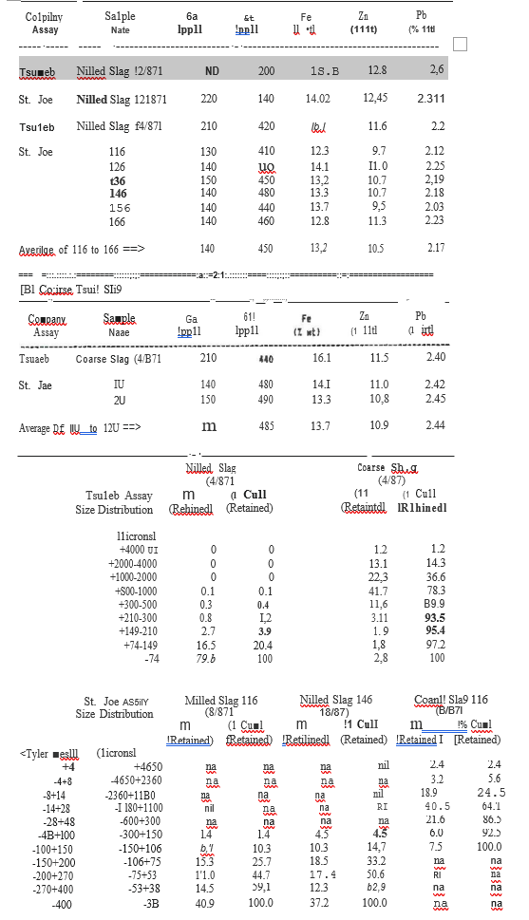

ANNEXURE 2

CHEMICAL ANALYSIS OF COAL USED FOR TESTWORK

|  |  |  |  |
| --- | --- | --- | --- |
|  |  | Eagle Hills Seam | S.A. Coal |
| Gross | (%) | 32,4 | 26,9 |
| Fixed Carbon | (%) | 51,9 | 55,8 |
| Volatiles | (%) | 39,1 | 28,9 |
| Ash | (%) | 7,0 | 15,3 |
| Moisture | (%) | 2,0 | 1,3 |
| Sulfur | (%) | 1,1 | 1,4 |

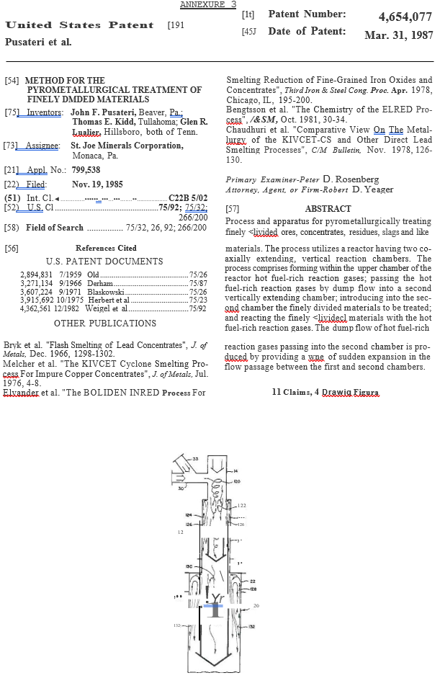

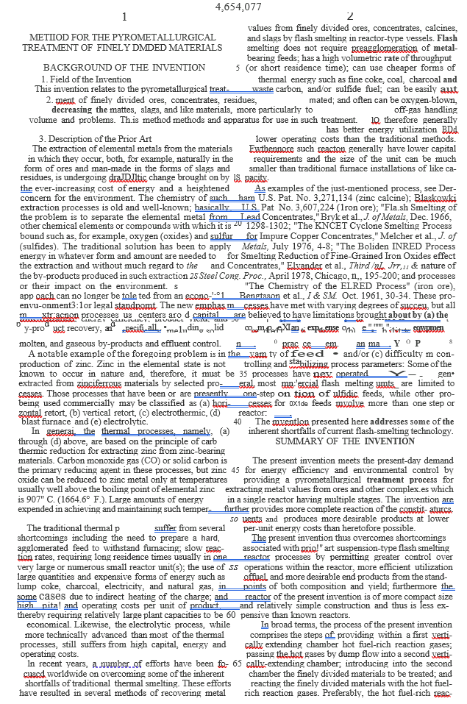

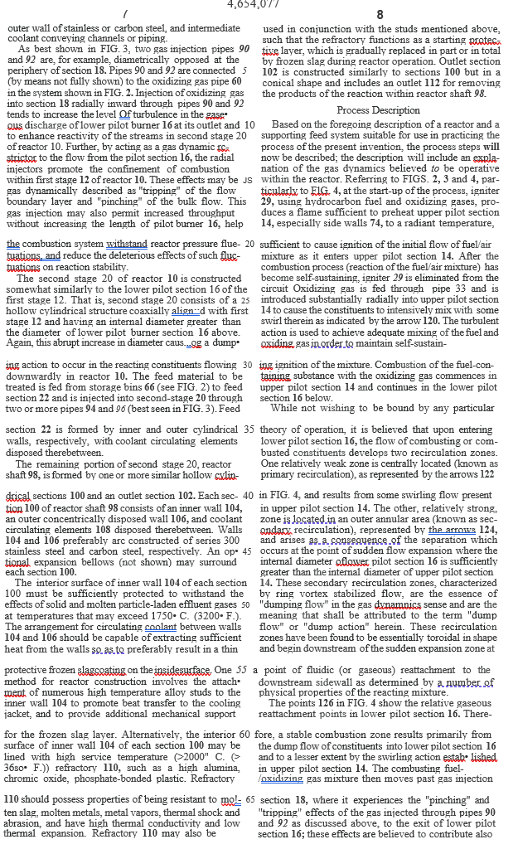

ANNEXURE 5

5. Test Trails Completed Before August 28

|  |  |  |  |  |  |  |  |  |  |  |  |  |
| --- | --- | --- | --- | --- | --- | --- | --- | --- | --- | --- | --- | --- |
| Test Point Number |  | 5A | 1B | 2B | 3B | 4B | 5B | 6B | 7B | 8B | 5C | 8C |
| Slag Feed Rate | (lb/m.) | 50 | 40 | 60 | 40 | 60 | 40 | 60 | 40 | 60 | 40 | 60 |
| Fuel Feed Rate | ( lb/m.) | 23,6 | 18,3 | 24,1 | 17,9 | 19,0 | 23,7 | 24,7 | 18,8 | 24,2 | 24,2 | 24,9 |
| % 1n Oxidant | (%) | 50 | 50 | 50 | 70 | 70 | 50 | 50 | 70 | 70 | 50 | 70 |
| CO/CO2 Ratio | (-) | 0,4 | 0,25 | 0,25 | 0,25 | 0,25 | 0,50 | 0,50 | 0,50 | 0,50 | 0,50 | 0,50 |
| Temperature | (OC} | 1700 | 1600 | 1800 | 1800 | 1600 | 1800 | 1600 | 1600 | 1800 | 1800 | 1800 |
| Fuel Conveying Air | (Scfm) | 30 | 30 | 30 | 30 | 30 | 30 | 30 | 30 | 30 | 30 | 30 |
| Feed Conveying Air | (Scfm) | 120 | 120 | 120 | 120 | 120 | 120 | 120 | 120 | 120 | 120 | 120 |
| 02 To Upper Pilot | (Scfm} | 244 | 98 | 142 | 190 | 90 | 120 | 200 | 123 | 121 | 124 | 130 |
| N2 To Upper Pilot | (Scfm) | 201 | 76 | 140 | 29 | 33 | 98 | 127 | 18 | 25 | 102 | 55 |
| 02 To Gas Injection | (Scfm} | 244 | 292 | 380 | 190 | 312 | 360 | 300 | 245 | 363 | 370 | 370 |
| N2 To Gas Injection | (Scfm) | 201 | 226 | 296 | 29 | 33 | 294 | 279 | 36 | 75 | 305 | 55 |

|  |  |  |  |  |  |  |  |  |  |  |  |  |
| --- | --- | --- | --- | --- | --- | --- | --- | --- | --- | --- | --- | --- |
|  |  | Coke | Coal | Coal | Coal | Coal | Coal | Coal | Coal | Coal | Coke | Coke |
| Date Of Trial | (August, 1987) | 13 | 24 | 24 | 19 | 24 | 25 | 21 | 21 | 25 | 26 | 26 |
| Duration Of Trial | (mins.) | 170 | 120 | 120 | 200 | 120 | 120 | 60 | 130 | 120 | 180 | 90 |
| Predicted Zn Recovery | (%) | 97,6 | 93,8 | 97,7 | 97,3 | 89,2 | 98,5 | 96,3 | 95,9 | 98,5 | 98,5 | 98,5 |

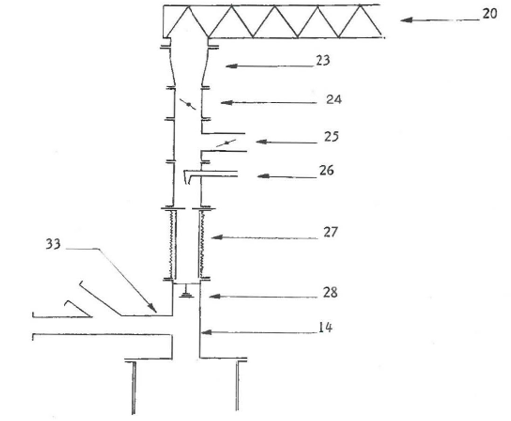

INTER-OFFICE_CORRESPDNDENCE

To Mr. C Viljoen

From Dr J Lauenstein

22.02.1990

Metallurgical R & D Report No. 93

Zinc, germanium and gallium distribution in different slag phases from the copper reverb slag at the Tsumeb Smelter.

1. Introduction:

With the test work for a zinc- and germanium fuming plant in progress it should be investigated, whet 1er so1Y1e of tl·1e v, d.ur.:1ble products in the slag, especially zinc germanium and gallium are enriched in certain slag phases, which might be extracted from the slag before fuming.

2. Procedure:

A composite sample of reverb slag was received from the smelter and several pellet mounts were made up and investigated under the microscope. The best two pellet mounts were used to mark all the Major phases in the slag with a diamond. These pellets were than taken to the MINTEK microprobe were the Major elements cf the different phases were determined. Then the quantitative distribution of the elements zinc, germanium and gallium in the different phases were determined. The way the standards far the Micraprobe were set up only allows a relative comparison of the assay values. The absolute values are not at all reflecting the correct absolute values.

3. Results:

The results are listed in table 1.

Figure 1

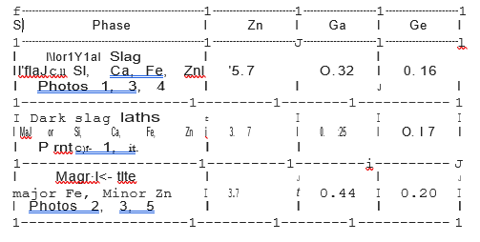

4. Conclusions:

Enrichments of Germanium and gallium were only found in lead drops and copper drops, which only made up a small fraction of the total weight. Therefore, it is not feasible to use methods of pre- enrichment of the slag products before slag fuming.

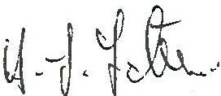

H.J. Lauenstein

cc.: E. Meyer

Photo 1

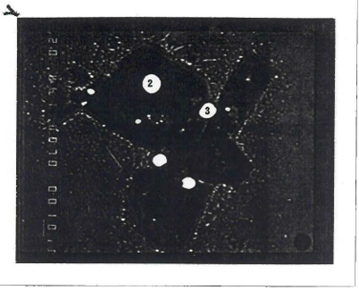

1. Normal slag 2. Dark Slag 3. Lead drops

Photo 2

4. Magnetite 5. Pb – Fe- Zn Phase, 6. Copper drop 7. Matte

Photo 3

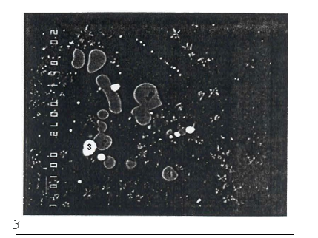

1. Normal Slag 3. Lead Drops 4. Magnetite

Photo 4

1. Normal slag 2. Dark Slag 3. Lead drops

Photo 5

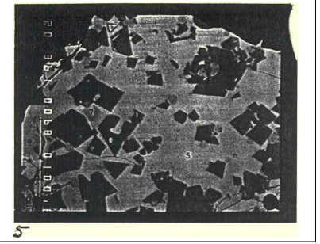

1. Magnetite 5. Pb – Fe – Zn Phase 7. Matte